INTRODUTION TO NETWORK

1.Draw a simple diagram (hand-drawn or digital) showing how your phone connects to Instagram, including your device, Wi-Fi router, ISP, and Instagram server. Label each part and the connections.
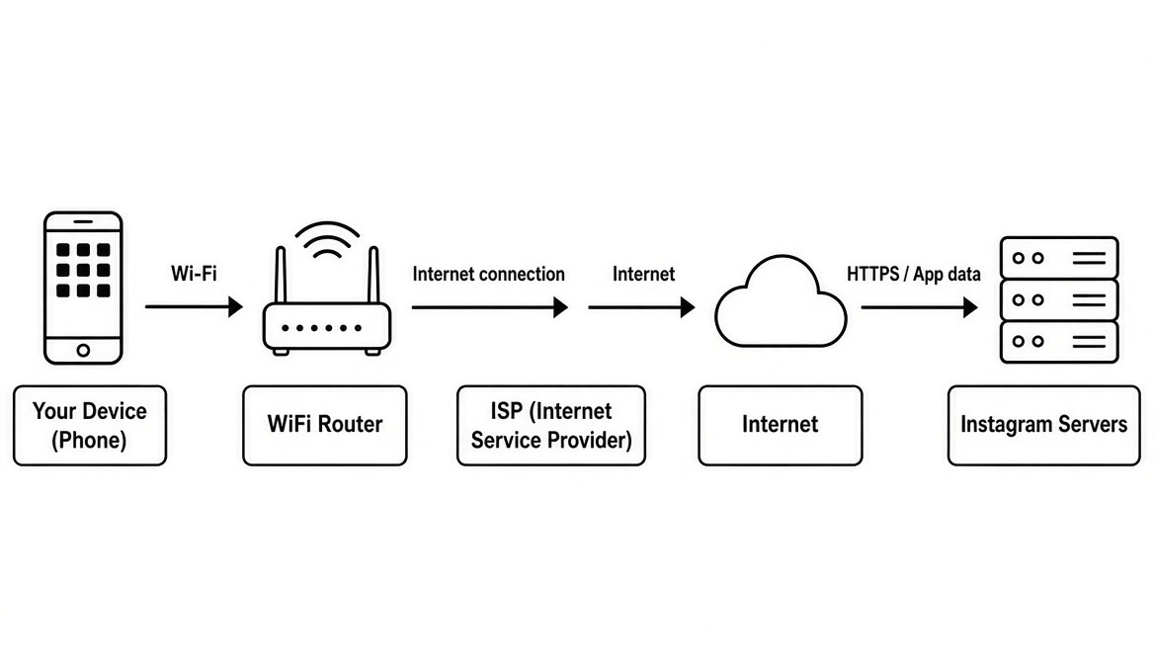
2. List 5 devices you use or see daily that are part of a network (for example: smartphone, smart TV, WiFi router, laptop, smartwatch). For each, write what type of network it connects to (LAN, WAN, PAN, etc.).
Answer
Here are five common daily devices and the types of networks they use.
1. Smartphone
- Network Type: WAN (Wide Area Network) and WLAN (Wireless Local Area Network)
- How it connects: It links to cell towers for mobile internet and to Wi-Fi for home networks.
2. Smart TV
- Network Type: LAN (Local Area Network)
- How it connects: It links to your home router through Wi-Fi or a wired cable to stream movies.
3. Wi-Fi Router
- Network Type: LAN and WAN
- How it connects: It builds your local home network and plugs into the wider internet provider network.
4. Laptop
- Network Type: LAN (Local Area Network)
- How it connects: It joins your home or office network to share files and browse websites.
5. Smartwatch
- Network Type: PAN (Personal Area Network)
- How it connects: It uses Bluetooth to link closely with your smartphone.

3. Explain the difference between the Internet and an intranet using an example from your college or a public Wi-Fi you have used.
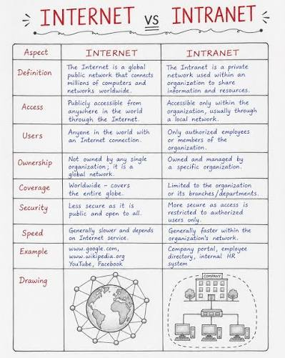

4. Pick any one app you use (like WhatsApp, Zomato, or Flipkart) and describe, in 4-5 lines, how data travels from your device to their server and back when you perform a search inside the app. Mention the devices and networks involved, and what happens when you hit 'search'.
Answer
- Your phone (the app) creates a search request and sends it over Wi-Fi (or mobile data) to your Wi-Fi router.
- The router forwards the request through your ISP onto the public Internet (WAN).
- The request travels across the Internet and reaches Flipkart’s servers.
- Flipkart’s servers process the search, find matching products, and send the results back along the same path.
- Your phone receives the data and the app displays the product list on your screen.

